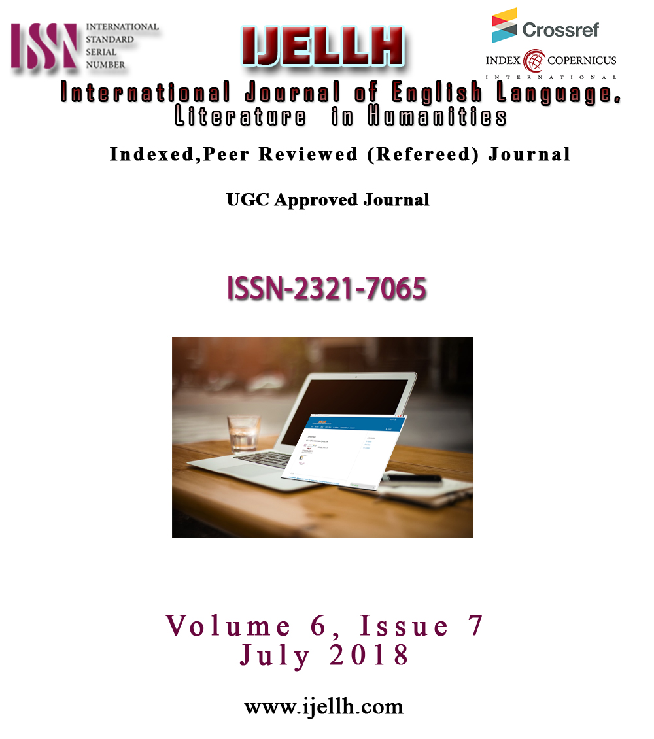

*G.Hemanatchatra
PhD Research scholar

** Dr.B.J.Geetha
Assistant Professor
Periyar University,
Salem,
India
hemanatchatraelt@gmail.com

Enhancing Writing Skills for Children with Learning Disabilities

Abstract
Focused heterogeneous group for the study , children with learning disabilities “... a disorder in one or more of the basic psychological processes involved in understanding or in using language, spoken or written, that may manifest itself in an imperfect ability to listen, think, speak, read, write, spell” Nakra 6. Learning disability is a specific impairment of academic learning that affects children’s academic development and progress. It is not that LD children cannot learn they may delay in listening, speaking, reading and writing, but they will learn if those children get education in the way they want.
Thirty samples were taken for the study, which includes children with dyslexia and ADHD (Attention Deficit Hyperactivity Disorder). The difference between others and LD children, LD children are able to grab the classroom teaching but they want in a different way. According to Kawashima, “the left brain is analytical while the right brain is creative”. The general classroom teaching is in analytical way but LD children want it in creative way. Since LD children demand teaching in creative way, given activities also focused to active right hemisphere of the brain. After few evaluations the researcher find out individual learning style of the thirty samples, there are visual learners, auditory learners and kinesthetic learners. In order to develop their writing skills various material tools were given. Pre and post assessments were also done, in the result researcher noticed tremendous development in their written language.
Keywords: LD (Learning Disability), ADHD (Attention Deficit Hyperactivity Disorder), individual learning style, writing skills.

The present paper explores the process of writing skills to children who experience difficulties in learning languages due to their attention deficit and hyperactivity disorder and dyslexia, Children with learning disabilities “... a disorder in one or more of the basic psychological processes involved in understanding or in using language, spoken or written, that may manifest itself in an imperfect ability to listen, think, speak, read, write, spell” (Nakra.p.6) Learning disability is a specific impairment of academic learning that affects children’s academic development and progress. It is not that LD children cannot learn they may delay in listening, speaking, reading and writing, but they will learn if those children get education in the way they want.
Thirty samples were taken for the study, which includes children with dyslexia and ADHD (Attention Deficit Hyperactivity Disorder). Natalia Turketi says “Attention Deficit Hyperactivity Disorder has long been considered Learning disability called a Minimal Brain Dysfunction that result in the lack of Concentration, impulsivity, restlessness and a way of processing information that is different from that of other learners. Recently, it has been classified as one of the Learning Disorders (or Differences) caused by a specific brain development” (Turteki.P.2). Children with ADHD have minimal brain dysfunction that results in lack of attention. Learning language is a big deal for them.
Catwell says “50% of children with ADHD have a different speech and language disorders caused by a central nervous system dysfunction” (Cantwell.P.20). Few studies identify the language abilities of ADHD child are affected by a deficit of working memory (Witton.P.8). Even the problem arise when the children acquires their first language and most of them have difficulties in Listening, Speaking, Reading and Writing in their native language itself (Sparks.P.42). In normal classroom, children with ADHD take too much information; they watch and hear many things. Their sensory receptors are constantly at work. Those children will do whatever attracts them and they cannot concentrate on teacher in classroom. Too much information often creates a chaotic state in their brain and the children cannot resist their distractions. This is the main reason for their learning disability and academic failure. Normal way of teaching will not be applicable to children with LD.
The difference between others and LD children, LD children are able to grab the classroom teaching but they want in a different way. According to Kawashima, “the left brain is analytical while the right brain is creative”. The general classroom teaching is in analytical way but LD children want it in creative way. Since LD children demand teaching in creative way.
The activity given for the children does not follow specific methodology. Since focused group of children are ADHD and Dyslexic, researcher decided not to follow concrete methods to teach them. Instead researcher chose abstract methods according to the interest and individual learning style. In order to enhance the children’s writing skills, researcher has given five main activities. Sessions were planned for forty minutes per activity. The following activities were repeated twice to complete the sessions.
- Creating a paragraph by topic sentence
- Writing story from shuffled random words
- Write letters to their favourite person
- Expression of thoughts through a note
- Explaining the children dreams / their wish
While creating paragraphs from topic sentence, children are often diverted from the activity. Since 17 of them have ADHD, research found it very difficult to have their attention in this particular activity. Among thirty children 12 of them were completed the first set of activity. Next two activities were completed as planned in the first set itself. In writing the expression of thoughts through note, 28 children completed the session other two were stopped in the middle. For explaining their dreams, 25 children completed. The incomplete sessions were dropped for the next set of activities. 2nd and 3rd sessions were repeated for those who did not complete other sessions properly.
Outcome of the samples progress in writing activities

Blue bar indicates total children who were all completed the first session activity. Red bar indicates total children who were all completed the second session activity. In the second session itself all the thirty children were able to perform completely so there is no need of next sessions.
Researcher has found out that children with learning disabilities were able to enhance their writing skills through given activities.

References
Cantwell, D.P., Baker, L. (1987). Prevalence and Type of Psychiatric Disorder and
Developmental Disorders in Three Speech and Language Groups, 20, 151-160.
Nakra,Onita (1996). Children with Learning Difficulties. Allied publishers private.
Limited.5.
Sparks, R., Ganschow, L., Pohlman, J., Skinner, S., Artzer, M. (1992). The effect of
multisensory structured language instruction on native language and foreign language
aptitude skills of at-risk high school foreign language learners. Annals of Dyslexia, 42,
25-53.
Turketi, Natalia,(2010).Teaching English To Children With ADHD. MA TESOL
Collection.p.483.
Witton, C., Talcott, J.B., Hansen, P.C., Richardson, A.J., Griffiths, T.D., Rees, A.,
Stein,J.F., Green, G.G. (1998). Sensitivity to dynamic auditory and visual stimuli
predicts onward reading ability in both dyslexic and normal readers, 8, 793-796

